**Name: jobin t j**

**Roll No:7**

**Batch:mca - B**

**Date:9/5/2022**

**NETWORKING & SYSTEM ADMINISTRATION LAB**

**Experiment No.: 1**

**Aim**

write a shell script to display current date and calendar

**Procedure**

**echo "Today is $(date)"**

**echo** ""

**echo** "Calendar :"

**cal**

**Output Screenshot**

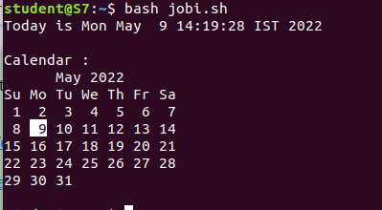

**Experiment:2**

**Aim**

write a shell script to check the number is greater than,less than,equalto another number

**Procedure**

**echo "enter a first number1 "**

**read number1**

**echo "enter a second number2"**

**read number2**

**if [ $number1 -eq $number2 ]**

**then**

**echo "$number1 -eq $number2 : a is equal to b"**

**else**

**echo "$number1 -eq $number2: a is not equal to b"**

**fi**

**if [ $number1 -ne $number2 ]**

**then**

**echo "$number1 -ne $number2: a is not equal to b"**

**else**

**echo "$number1 -ne $number2 : a is equal to b"**

**fi**

**if [ $number1 -gt $number2 ]**

**then**

**echo "$number1 -gt $number2: a is greater than b"**

**else**

**echo "$number1 -gt $number2: a is not greater than b"**

**fi**

**if [ $number1 -lt $number2 ]**

**then**

**echo "$number1 -lt $number2: a is less than b"**

**else**

**echo "$number1 -lt $number2: a is not less than b"**

**fi**

**if [ $number1 -ge $number2 ]**

**then**

**echo "$number1 -ge $number2: a is greater or equal to b"**

**else**

**echo "$number1 -ge $number2: a is not greater or equal to b"**

**fi**

**if [ $number1 -le $number2 ]**

**then**

**echo "$number1 -le $number2: a is less or equal to b"**

**else**

**echo "$number1 -le $number2: a is not less or equal to b"**

**fi**

**Output Screenshot**

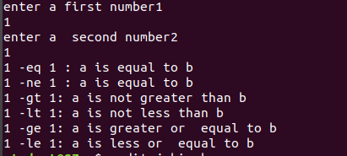

**Experiment No.: 3**

**Aim**

sum of first 10 numbers in shell script

**Procedure**

**echo "Enter Size(N)"**

**read N**

**i=1**

**sum=0**

**echo "Enter Numbers"**

**while [ $i -le $N ]**

**do**

**read num**

**sum=$((sum + num))**

**i=$((i + 1))**

**done**

**echo $sum**

**Output Screenshot**



**Experiment No.: 4**

**Aim**

write sum of average product of 4 number shell script

**Procedure**

**echo "enter four integers"**

**read a b c d**

**sum=$(echo "$a + $b + $c + $d" | bc -l)**

**average=$(echo "$sum / 4" | bc -l)**

**product=$(echo "$a * $b * $c * $d" | bc -l)**

**echo "sum = $sum"**

**echo "Average = $average"**

**echo "Product = $product"**

**Output Screenshot**

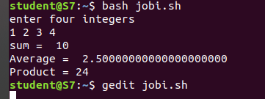

**Experiment No.: 5**

**Aim**

write a shell script to find a factorial of a number

**Procedure**

**echo "Enter a number"**

**read num**

**fact=1**

**while [ $num -gt 1 ]**

**do**

**fact=$((fact * num)) #fact = fact * num**

**num=$((num - 1)) #num = num - 1**

**done**

**echo $fact**

**Output Screenshot**

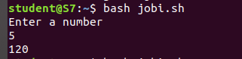

**Experiment No.: 6**

**Aim**

write sum of average product of 4 number shell script

**Procedure**

**Experiment No.: 4**

**Aim**

write a shell script to find a number is palindrome or not

**Procedure**

**e**cho "Enter the number"

read n

function pal

{

number=$n

reverse=0

while [ $n -gt 0 ]

do

a=`expr $n % 10 `

n=`expr $n / 10 `

reverse=`expr $reverse \* 10 + $a`

done

echo $reverse

if [ $number -eq $reverse ]

then

echo "Number is palindrome"

else

echo "Number is not palindrome"

fi

}

r=`pal $n`

echo "$r"

**Output Screenshot**

